Allegato 4
M.E.O.W.S.

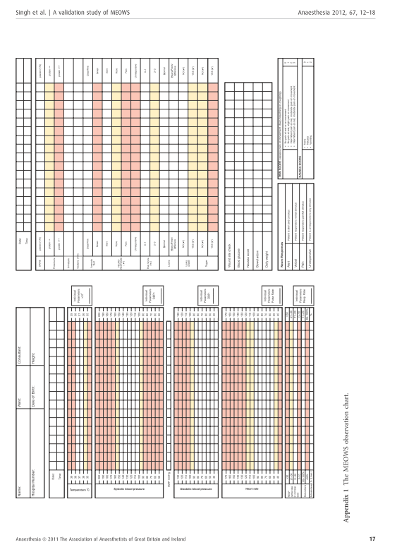

M.E.O.W.S.: Modified Early Obstetric Warning Score (Singh, 2012).

