# Allegato 3

**N.E.W.S.**

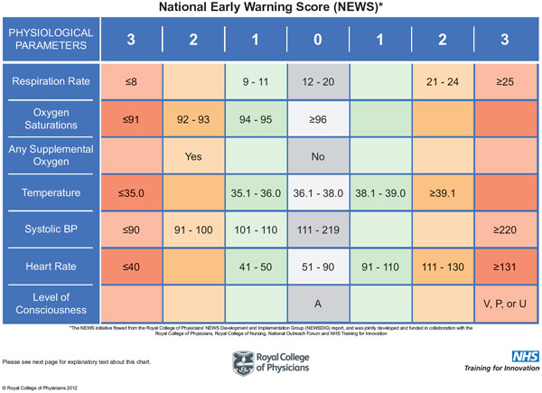

**N.E.W.S: National Early Warning Score (Royal College of Physicians 2012).**