# Allegato 4

**M.E.O.W.S.**

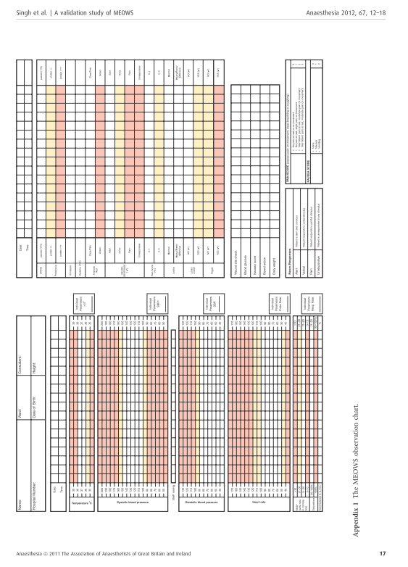

**M.E.O.W.S.: Modified Early Obstetric Warning Score (Singh, 2012).**